**SIMM16 ASSIGNMENT : ANALYSE THE IMPACT OF EDUCATION TO INFLUENCE THE SOCIO-DEMOGRAPHIC PROFILE CONCERNING THE OCCUPATION AND INCOME WITHIN THE UK PEOPLE**

Introduction

Socio-demographic factors are extensively influential on educational outcomes; however, limited research endeavoured to analyse the essence of education to influence the socio-demographic profile concerning the income and occupation of the UK people. As discussed by Sharma & Jain (2020), middle-level employees experience higher job satisfaction and less stress due to various reasons including more benefits, higher income, job security, etc.; however, entry-level officers are more stressed and hence their job satisfaction is affected. In addition, the occurrence of work stress is typically high among people of low socio-economic backgrounds due to less education rather than those having higher socio-economic backgrounds. In this essay, through the application of European Social Survey Data, the research question that focused on assessing the impact of education on influencing the socio-demographic profile concerning the income level and occupation of people in the UK will be performed.

Lastly the presentation within the distribution of the variable and relationship disclosing will be used in this study. Concerning the reliability of the data set cronbach alpha test will be used for this study. After that use of the bivariate analysis, univariate analysis and multivariate analysis will be taken into action for disclosing the relationship among the focal variables.

***Research Question:*** What is the impact of education to influence the socio-demographic profile concerning the occupation and income within the UK people*?*

# 

# Literature Review

**Article 1: Houtepen, L.C., Heron, J., Suderman, M.J., Fraser, A., Chittleborough, C.R. & Howe, L.D., 2020. Associations of adverse childhood experiences with educational attainment and adolescent health and the role of family and socioeconomic factors: a prospective cohort study in the UK. PLoS medicine, 17(3), p.e1003031.**

***Sampling strategy:*** The outcome of the research has been conducted with the inclusion of 9,959 samples. These samples have been chosen based on the probability sampling strategy.

***Missing data:*** The cohort study does not include the answers to all the questionnaires as the study was conducted over a longitudinal period. The research also lacks the inclusion of an interpretivism philosophy as the data findings have not been perfectly interpreted as per the research objectives. There have also been instances where certain respondents have replied to less than 50% of the questions in the questionnaire. This data has been subjected to missing data which cannot be derived from the research samples. The research is also missing a theoretical view from its cohort and does not reflect the application of any particular theory.

***Operationalization, validity and analytic strategy:*** As for developing the operational and validity of the data sets, a pragmatic approach has been applied. After that, a discussion-based analytical strategy was followed to analyse the collected data. The data counted as missing data was decided as smaller size, Furthermore, A single retrospective analysis was used to validate the data based on the data quality and data authentication. Therefore, this study reflects the single retrospective analysis as part of its operational and analytics strategy.

***Relationship between theory, research question and statistical analysis:*** As this study reflects a lack of theoretical underpinning, there is no particular relationship between the theory, research question and statistical analysis. Hence, this has not been included in the research question and statistical analysis.

***Different methodological choices:*** Pragmatic research choice with a probability sampling strategy has been applied in this study. A longitudinal study with data samples of children and parents has been used in this research.

***Summarisation of conclusion:*** The study concludes that lower educational attainment and worse health and health-related behaviour in adolescence are a projectile of robust variables. The lack of relationship between the theoretical perspective and statistical analysis along with research questions has been seen as a research gap which fails to address the research cohort properly.

***Empirical investigation:*** The empirical investigation suggests that the majority of the children associated with adolescence are faced with adverse childhood experiences. In this case, such adverse childhood experiences can shape them to a large extent and increase their intention for unhealthy social behaviour.

**Article 2: Lindberg, M.H., Chen, G., Olsen, J.A. & Abelsen, B., (2021). Explaining subjective social status in two countries: The relative importance of education, occupation, income and childhood circumstances. *SSM-Population Health*, *15*, p.100864. https://www.sciencedirect.com/science/article/pii/S2352827321001397**

***Sampling strategy:*** Targeted sampling which is also known as purposive sampling has been utilised in the study with a sample size of 1400 and demographic quotas have been applied. A sample of 1920 respondents was taken from Australia whereas 2418 in Norway initially. However, after the exclusion, the Australian sample size was 1423 and the Norwegian sample size was 1400.

***Missing data:*** The study reflects the risk of selection of bias within the recruitment approach if sex and age quotas were applied thereby acting as a limiting factor. Samples might not be representative of within a short period and thus certain groups could be overrepresented in the study which acts as a limiting factor. The distribution of respondents differed across education levels between the samples leading to a limitation within the study.

***Operationalisation, validity and analytic strategy:*** The study makes use of a comparative analysis of the education level and its impact on income between the population of Norway and Australia. The study makes use of a large sample size thereby collecting first-hand data contributing to validate the research study. The quantitative analytical strategy has been implemented in the study which acts as a critical advantage.

***Relationship between theory, research question and statistical analysis:*** The study theories the pathway from SEP or socioeconomic position to adult health by making subjective comparisons. The statistical analysis implemented in the study acts as a crucial aspect for analysing large data sets and helps in answering how the variables are related to one another.

***Different methodological choices:*** The study utilises statistical analysis where the data has been collected using a survey that was developed on the online platform. The study utilises descriptive statistics, ordinary least square regression analysis and statistical graphs to reflect the results that have been obtained from the dataset. The statistical analysis contributes to a simplified interpretation of research findings and provides an effective approach to the study.

***Summarisation of conclusion:*** The study reflects the need for intervention in policy affecting SEP like reduced income inequalities and improved social inclusion policies. It is critical to understand the mechanisms between objective and subjective SEP influencing the institutional factors.

***Empirical investigation:*** Income has been observed to be the strongest predictor of subjective SEP in Australia whereas occupation has been observed to be strongest in Norway. Childhood circumstances are connected with subjective SEP despite controlling objective SEP.

**Article 3: Wędrowska, E. and Muszyńska, J., 2022. Role of age and education as the determinant of income inequality in Poland: decomposition of the mean logarithmic deviation. *Entropy*, *24*(6), p.773. https://www.mdpi.com/1099-4300/24/6/773**

***Sampling strategy:*** For conducting this research article, the purposive sampling method has been considered by using a cross-sectional EU-SILC data set that spanned 16,263 households. Also, 49,044 individuals and 19,874 households with 50,788 persons have been used for conducting this study.

***Missing data:*** In this context, it has been identified that due to the restricted information on the education and age of the individual, the amount of observation is quite limited such as 48,916 individuals in 2005 and 43,935 persons in 2019. On a similar note, the authors of the research study omitted 117 observations with zero and negative incomes in the year 2005 and overlooked 103 such observations in 2019. Based on this, it can be stated that the data collection has been conducted from 2005 to 2019 and it is unable to give accurate data as per the current market situation.

***Operationalization, validity and analytic strategy:*** This research study creates a comparative analysis between age and education as a determinant of income inequality in Poland. In addition, a split inequality measure has been considered which has been included with four different categories such as combinatorics, entropy, deviations, and social-welfare function. Therefore, these methods help to analyse each variable and provide accurate data as well.

***Relationship between theory, research question and statistical analysis:*** For conducting this research article, statistical information theory has been used which helps to provide accurate information about income inequality and education. Moreover, the concept of information theory is one of the major parts of income inequality. The Mean Logarithmic Deviation has been used by the researcher for statistical analysis.

***Different methodological choices:*** This research study has been employed with the EU-SILC survey which has been conducted on an EU-wide household survey that delivers data on the income and living circumstances of a sample of households. On a similar note, overall data has been extracted from the cross-sectional database of the EU-SILC 2019. Additionally, correlation and regression methods have been used for statistical analysis as well. The MLD was chosen by the researcher to analyse the variable as well.

***Summarisation of conclusion:*** In this context, it has been identified that education plays an important role in increasing or decreasing the income of an individual. For instance, based on high education, individuals get a high-paying job which helps to enhance their well-being and lifestyle as well.

***Empirical investigation:*** In the empirical analysis, the authors of the research study focus on the annual equivalised household disposable income per household individual. Also, the entire household disposable income has been computed as a sum of entire gross personal income elements for entire household individuals and gross income elements at the household standards minimised by taxes, social insurance contributions, and inter-household cash transfers paid.

Empirical Analysis

## 2.1 Selection of the Dataset

The study makes use of ESS or European Social Survey Data has been selected to analyse the impact of education on occupation and income in the UK people. The selected variable for downloading the data has been used as ***“Socio-Demographic Profile, Including Type of area, education and occupation, union membership, income, marital status”***. 10 rounds were conducted (2002-2022) and all-around data has been reflected in the study. The Socio-demographic profile is the standard value that has been considered in the study where the population size of 20979 has been considered. Education, income and occupation are the selected variables in the study that will contribute to an in-depth understanding of the socio-demographic profile in the UK.

## 2.2 Construct of Index (Education: dependent variable)

In this context, it has been identified that education has been considered as a dependent variable which has a significant impact on the occupation and income. Therefore, in the rotating module ESS, participants were asked on a measuring scale that based on whether they agree or disagree with the multiple perspectives of the education in the UK. Based on the below figure, it has been identified that the first 5 scale has come under the International Standard Classification of Education (ISCED) which helps to summarise the data and provide an accurate picture about the data set. On the other hand, scale stated from 55 to 99 are not consider under International Standard Classification of Education (ISCED), thereby, it is not used as a measuring scale as well.

|  |  |  |  |  |  |  |  |  |  |  |
| --- | --- | --- | --- | --- | --- | --- | --- | --- | --- | --- |
| **Names of Variables** | | | | | | | | | | |
| Education | Not possible to harmonise into 5-level ISCED | Less than lower secondary education (ISCED 0-1) | Lower secondary education completed (ISCED 2) | Upper secondary education completed (ISCED 3) | Post-secondary non-tertiary education completed (ISCED 4) | Tertiary education completed (ISCED 5-6) | Other | Refusal | Don’t know | No answer |
| Occupation | Employee | Self-employed | Working for own family business | Not applicable | Refusal | Don’t know | No answer |  |  |  |
| Income | Wages or salaries | Income from self-employment or farming | Pensions | Unemployment/redundancy benefit | Any other social benefits or grants | Income from investment, savings, etc. | Income from other sources | Refusal | Don’t know | No answer |

**Table 1: Variables**

(Source: Self-Developed)

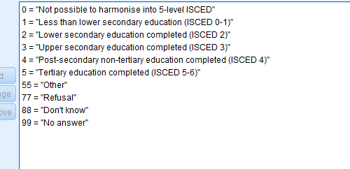

**Figure 1: Measuring scale for considering the depend variable**

(Source: Refer to the dataset)

## 2.3 Selection of Focal Variable

Education is considered the dependent variable which influences income and occupation to a critical extent. A measuring scale has been utilised in the study using ESS for providing options to participants to select from as per the education levels which is suitable among the options. ISCED or International Standard Classification of Education has been utilised in the study to reflect on the level of education of participants which has been selected by different participants as per their education levels. For instance, 0 stands for “not completed ISCED Level 1” whereas 9999 stands for “ No answer”.

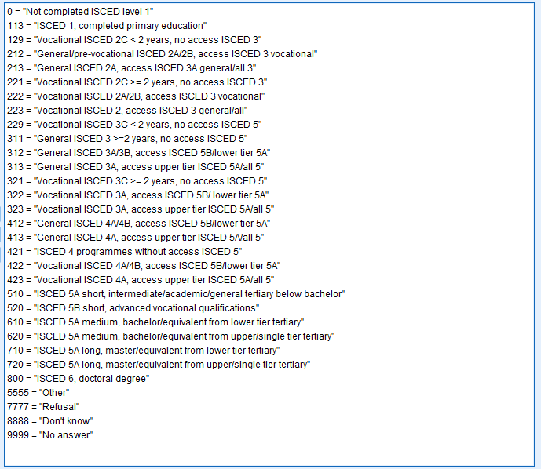**Figure 2: Measuring Scale**

(Source: Refer to the Dataset)

## 2.4 Description of Focal Relationship



**Figure 3: Measuring Scale**

(Source: Refer to the Dataset)

In this context, it can be depicted that education has a significant impact on the occupation of an individual and it can be stated that highly educated people can get the high paid jobs as well. For instance, achieving a degree in engineering helps to earn a salary like £75,000 or more than that (Thecompleteuniversityguide, 2023). Based on this, it can be depicted that education has the ability that it can influence occupations as well. Therefore, in this context, different 7 measuring scale has been used which helps to get the accurate result about the survey as well.

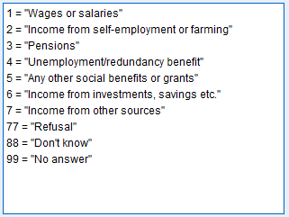

**Figure 4: Measuring Scale**

(Source: Refer to the Dataset)

On the other hand, it has been identified that education has the ability to influence the major source of household income. For collecting the accurate result of the survey, it seems that 7 different measuring scale has been considered which has been comes under the ISCED and other 3 measuring scales are not considered a part of the ISCED.

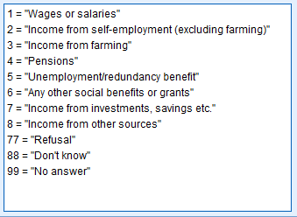

**Figure 5: Measuring Scale**

(Source: Refer to the Dataset)

However, in the context of the refined scale of household income, 7 different measuring scales have been considered which have come under the ISCED. For instance, the first scale is wages or salaries which helps to provide an accurate picture about the household income based on the wages and salaries as well.

## 2.5 Analysis of the Reliability and Internal Consistency of the Variable

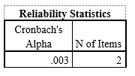

**Figure 6: Cronbach Alpha**

Based on the above calculation of Cronbach Alpha, it has been identified that the total number of items stood at 2 along with the value of Cronbach Alpha of .003. Based on this, it can be depicted that items are not representative of the domain of behaviour and it is considered as the lowest possible value as well.

## 2.6 Analysis of the Focal Variable (Univariate Analysis)

### 2.6.1 Univariate Analysis of the Dependent Variable

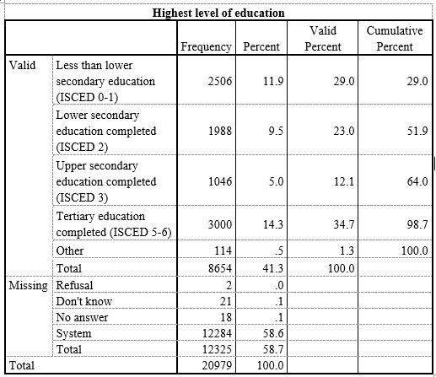

**Figure 7: The highest level of education**

Based on the aforementioned figure, it has been identified that it focuses on the highest level of education of UK individuals. Therefore, it seems that the total number of individuals is 20979 and only 8654 people share their perspective to make it accurate. Hence, the first option is less than lower secondary education (ISCED 0-1) which holds a frequency of 2506 along with the 11.9% which reflects that 2506 people have less than lower secondary education, on the other hand, lower secondary education completed (ISCED 2) has a frequency of 1988 with 9.5%. Based on this, it can be stated that only 1988 individuals of 20979 completed lower secondary education. Apart from this, in the context of upper secondary education completed (ISCED 3), it has a frequency value of 1046 along with 5%. It addresses that 1046 of individuals completed upper secondary education. Lastly, tertiary education completed (ISCED 5-6) has a frequency of 3000 with 14.3%. Based on this, it can be depicted that 3000 people have higher levels of education. Another 12325 people do not share their aspect in terms of their education as well.

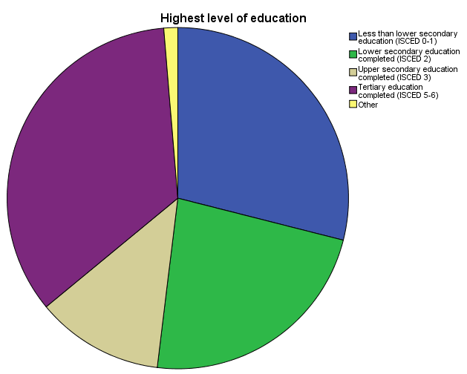

**Figure 8: Highest Level of Education**

From the above pie-chart, it has been very clear that the highest level of education completed by the people in the UK is found to be ***tertiary education*** with a frequency of 3000, which is followed by ***less than lower secondary education*** that has reached a frequency of 2506.

|  |
| --- |
|  |

**Figure 9: The highest level of education**

In regard to Figure 7, it has been identified that the descriptive statistics have been based on the highest level of education. Therefore, in the context of the first option not completing ISCED level 1, the frequency is 16 along with the .1% which addresses that only 16 individuals are unable to complete ISCED. On a similar note, for the second component, 2595 individuals completed the primary question or ISCED 1. Therefore, as per the above figure, it seems that the majority of individuals completed the primary questions.

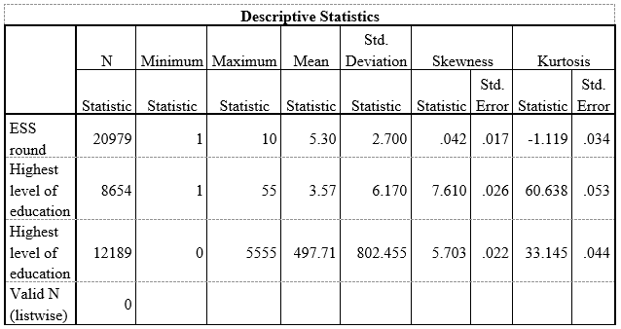

**Figure 10: Descriptive Statistics**

The figure presented above reflects the descriptive statistics for the highest level of education where the mean and standard deviation have been calculated for the selected variables. The mean value for the ESS round has been observed to be 5.30, and the highest level of education has been observed to be 3.57 in the first stage. In contrast, the highest level of education has been observed to be 491.71 in the second stage. The skewness value has been observed to be 0.42 for the ESS round, highest level of education in the first stage is observed to be 7.610 and is further observed to be 5.703 in the second stage. This, therefore, indicates variability in data and positive skewness within the given dataset.

### 2.6.2 Analysis of Independent Variable

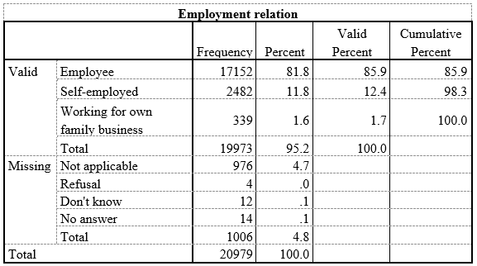

**Figure 11: Analysis of Employment Relations**

The figure presented above indicates the analysis of the independent variable which is the employment relation. The frequency for employees has been observed to be 17152, self-employed has been observed to be 2482, and working for own family business has been observed to be 339. The table further indicates that 976 were not applicable, 4 were refused, 12 stated don’t know and 14 have no answers. Hence a total of 1006 employment relations were missing in the dataset.

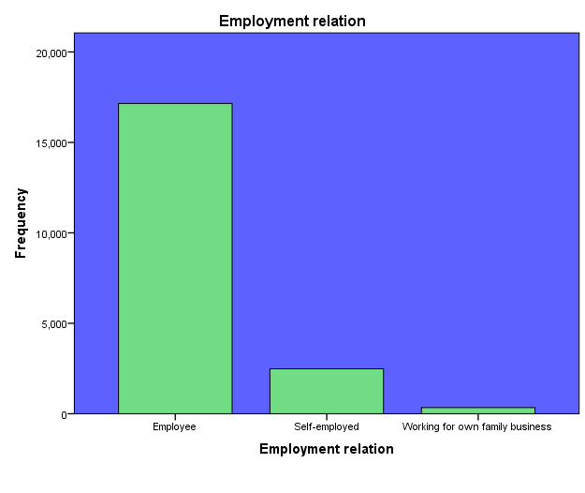

**Figure 12: Employment Relation**

From the above graph, it has been made very clear that the frequency of ‘***employee*’** is found to be 17152, which is followed by the frequency of ‘***self-employed***’ with the frequency of 2482 and lastly ‘***working for own family business*’** with a frequency of 339.

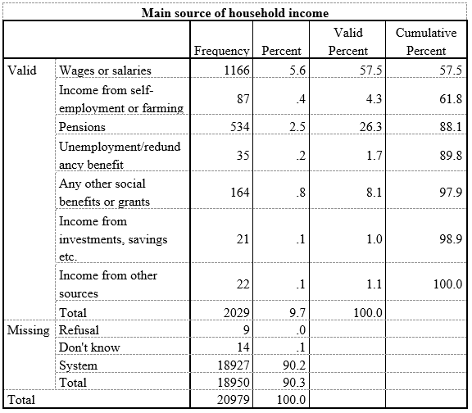

**Figure 13: Analysis of Household income**

The figure presented above reflects the main source of household income. The valid numbers have been observed to be 2029. Wages or salaries have been observed to be the main source of income as per 1166 respondents whereas pensions act as a major source for 534 respondents. Income from investments and savings has been identified as a main source of income by 22. The total number of missing data has been observed to be 18950 for the main source of household income as reflected by the respondents.

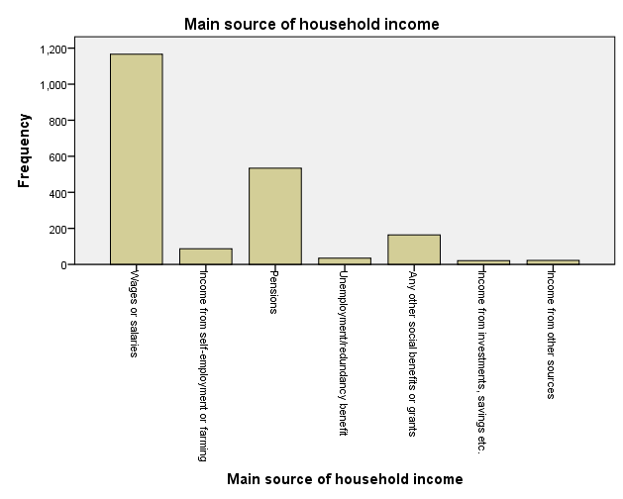

**Figure 14: Main Source of Household Income**

From the above bar graph, it has been unveiled that the main source of household income for most of the people in the UK is ‘***Wages or salaries***’ with a frequency of 1166. The next crucial source of household income is found to be ‘***Pension***’ with a frequency of 534. Another good source of household income is ‘***Any other social benefits or grants***’ with a frequency of 164. Apart from these three, the rest of the sources of household income is found to be very trivial.

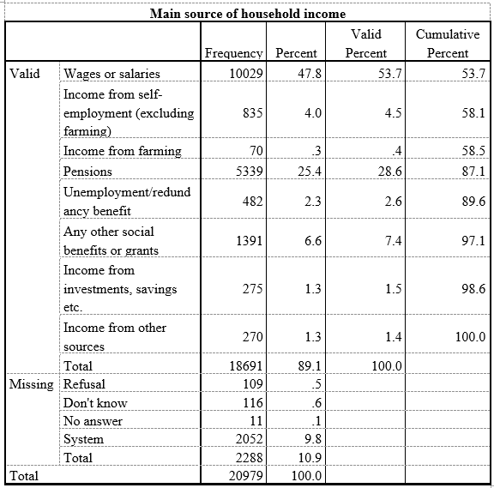

**Figure 15: Main source of household income**

The above figure focuses on the main source of household income among 20979 individuals. Therefore, only 18691 people shared their opinions about the sources of household income. It seems that wages and salaries have a frequency of 10029 along with 47.8%. Based on this, 10029 people stated that salaries or wages are their major sources of household income. On the other hand, income from farming holds a frequency value of 70 with .3%. Hence, as per the analysis, it can be depicted that the majority of individuals consider salaries or wages as their major sources of income as well.

## 2.7 Analysis of Focal Relationship

### 2.7.1 Bivariate Analysis

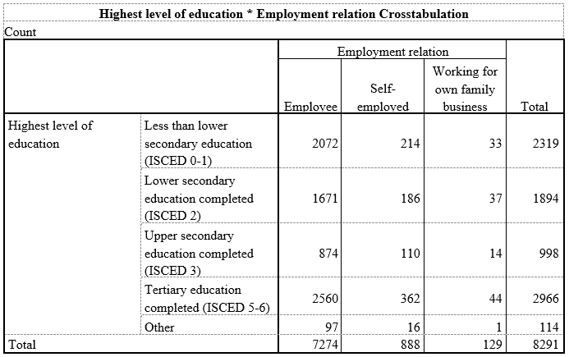

**Figure 16: Bivariate Analysis**

The figure presented above indicates the highest level of education in relation to employment relations. The results reflect that individuals that had received less than lower secondary education, 2072 were employees, 214 were self-employed, and 33 were working for their own family business. Of the individuals who had received lower secondary education among them, 1671 were employees, 186 were self-employed, and 37 working for their own family business. Of the individuals who received upper-secondary education, 874 were employees, 110 were self-employed and 14 were working in the family business. In contrast, individuals who received tertiary education completed, among them 2560 were employees, 362 self-employed, and 44 were working for a family business. Therefore, it can be stated that individuals who received ISCED 5-6 were mostly employees and only 44 were working for family businesses.

|  |
| --- |
|  |

**Figure 17: Cross Tabulation**

The figure presented above reflects cross-tabulation for the highest level of education and employee relations. The results reflect that individuals with ISCED 1 were mostly employees, and 51 were working in family businesses. However, of the individuals that have completed ISCED 3C, among them 68 were employees, 7 were self-employed and 1 was working in the family business. In contrast, individuals having ISCED 6 doctoral degrees, among them 963 were employees 194 were self-employed while 20 were working in family business. Hence, it can be stated that the level of education has an influence on the employment of individuals.

|  |
| --- |
|  |

**Figure 18: Cross tabulation for education and main source of household income**

The figure presented above reflects the cross-tabulation for education and its relation with the main source of household income. It has been observed that individuals having less than lower secondary education, 198 have wages as their main source of income, 15 are self-employed and 325 are dependent on pensions. In contrast, individuals who have received ICSED 2, 335 had wages as main source of income, 19 were self-employed and 75 had pensions as main source of income. Therefore, as a whole, it can be stated that the level of education had an impact on the main source of income for individuals.

### 2.7.2 Multivariate Analysis

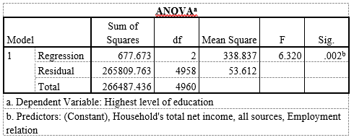

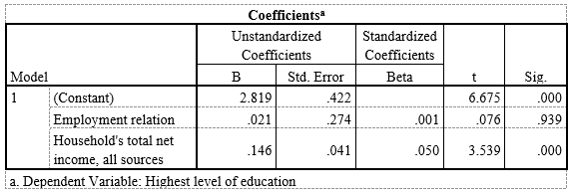

**Figure 19: Multiple regression analysis**

Based on the above figure, it has been identified that regression analysis has been conducted which helps to describe the relationship among different variables. Therefore, in the context of ANOVA, it seems that the sig value in regression stood at .002 which has been lower than 0.05, thereby, it is statistically significant if the dependent variable is considered as the highest level of education. On a similar note, in the context of coefficient, it has been identified that the sig value of employment relation stood at .939 which has been greater than 0.05, thereby, it is statistically insignificant. On the other hand, for a household's total income, all sources have a sig value of .000 which is statistically significant due to lower than 0.05 value. Thus it described that the education is widely influencing the employment and the income status of the individuals.

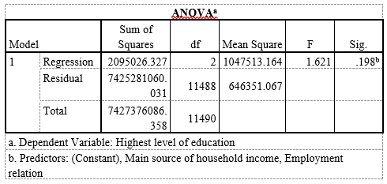

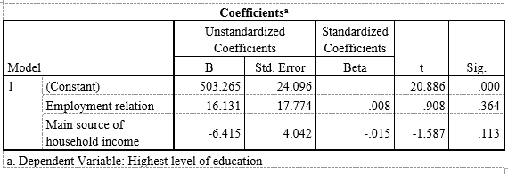

**Figure 20: Multiple regression analysis**

The above figure addresses the fact that the regression analysis has been used to demonstrate the relationship between different variables. Therefore, it seems that the sig value of regression stood at .198 which is statistically insignificant due to the higher than 0.05 value. On the other hand, the sig value of employment relation is observed at .364 which is statistically insignificant if the dependent variable is considered as the highest level of education.

## 2.8 Discussion of the Result

As suggested by Muijs (2010), it has been identified that based on the high value of education, individuals can control the external factors such as seeking high paid jobs, increasing income and much more. From the result section of this research, it can be seen that the total number of individuals is 20979 and only 8654 people share their perspective to make it accurate. From the table above it has been observed that the lower secondary education (ISCED 0-1) has a frequency of 2506 which is equivalent to a percentage of 11.9%. This states that nearly 2506 people have lower secondary education. On the other hand, the value for ISCED 2 has a frequency of 1988 which is equivalent to the percentage of 9.5%. The frequency and percentage for ISCED 3 have been obtained at 1046 and 5% respectively. The frequency and percentage for ISCED 5-6 have been obtained at 3000 and 14.3% respectively. The highest level of education has been observed to be 491.71 in the second stage. The value for skewness has been observed at 0.42 for the ESS round, the highest level of education in the first stage is observed to be 7.610. In this context, it can be seen that the adequate value for skewness has been observed -0.5 and 0.5 and the data set in this meridian is considered symmetrical (Spcforexcel, 2016). Thus, the data set is positively skewed.

On the other hand, as argued by Aneshensel (2012), it has been identified that theory-based data analysis is quite helpful for social science and analyses each factor in a more effective manner. The frequency for employees has been observed at 17152, self-employed has been observed at 2482, and working for one's family business has been observed at 339. The household income has been analysed as well. For instance, it has been observed that wages and salaries have been considered as the primary source of income for the respondents. In this context, it can be seen that the salaries, earnings and profits derived by the stakeholders are the primary source of income for households (Wallstreetmojo, 2024). The total number of missing data has been observed to be 18950 for the main source of household income as reflected by the respondents. From the cross-tabulation, it can be seen that the individuals with ISCED 1 are mostly employees, among which 51 employees are associated with family business. On the contrary, it can be seen that of individuals that have completed ISCED 3C, among them 68 were employees, 7 were self-employed and 1 was working in the family business. In contrast, individuals having ISCED 6 doctoral degrees, among them 963 were employees, 194 were self-employed and 20 were working in family business. Thus, it can be stated that the educational levels of the employees have a significant impact on the employment levels of the employees.

## 2.9 Summary

The study efficiently reflects the ways in which education influences occupation and household income. The survey conducted helped in providing critical insights on ways in which education is impactful to individuals. For instance, individuals that have completed ISCED 1, primary education are mostly employed and do services rather than having their own business. The data reflects that 3000 individuals have completed Tertiary education reflecting a valid percentage of 34.7 with the cumulative percentage of 98.7. Therefore, it can be understood from the results that income and occupation are highly dependent on the level of education of individuals. However, from the regression analysis it is evident that the education and employment are statistically insignificant but leads to an impact on overall income of individuals.

## 

## References

Aneshensel, C. S. (2012). Theory-based data analysis for the social sciences. Sage Publications.

<https://books.google.co.in/books?hl=en&lr=&id=_epyCQAAQBAJ&oi=fnd&pg=PP1&dq=Aneshensel,+C.+S.+(2012).+Theory-based+data+analysis+for+the+social+sciences.+Sage+Publications>.

Houtepen, L.C., Heron, J., Suderman, M.J., Fraser, A., Chittleborough, C.R. & Ho L.D., (2020). Associations of adverse childhood experiences with educational attainment and adolescent. Health and the role of family and socioeconomic factors: a prospective cohort study in theUK. PLoS medicine, 17(3), p.e1003031. <https://doi.org/10.1371/journal.pmed.1003031>

Lindberg, M.H., Chen, G., Olsen, J.A. & Abelsen, B., (2021). Explaining subjective social. Status in two countries: The relative importance of education, occupation, income and childhood circumstances. SSM-Population Health, 15, p.100864. <https://www.sciencedirect.com/science/article/pii/S2352827321001397>

Muijs, Daniel (2010). Doing Quantitative Research in Education With SPSS. (2nd ed.). London: SAGE. <https://books.google.co.in/books?hl=en&lr=&id=apFMQHF768EC&oi=fnd&pg=P&dq=Muijs,+Daniel+(2010).+Doing+Quantitative+Research+in+Education+With+SPSS.+(2nd+ed.).+London:+SAGE>.

Sharma, A., & Jain, V. (2020). A study of relationship of stress and demographic profile of employees with special reference to their marital status and income. UGC Care Journal, 43(4), 111-115. <https://www.researchgate.net/profile/Vipin-Jain-13/publication/345993001_A_STUDY_OF_RELATIONSHIP_OF_STRESS_AND_DEMOGRAPHIC_PROFILE_OF_EMPLOYEES_WITH_SPECIAL_REFERENCE_TO_THEIR_MARITAL_STATUS_AND_INCOME/links/5fb4df5da6fdcc9ae05efc51/A-STUDY-OF-RELATIONSHIP-OF-STRESS-AND-DEMOGRAPHIC-PROFILE-OF-EMPLOYEES-WITH-SPECIAL-REFERENCE-TO-THEIR-MARITAL-STATUS-AND-INCOME.pdf>

Spcforexcel, (2016). Are The Skewness And Kurtosis Useful Statistics? <https://www.spcforexcel.com/knowledge/basic-statistics/are-skewness-and-kurtosis-useful-statistics/>

Thecompleteuniversityguide, (2023) What are the highest paying degrees?. <https://www.thecompleteuniversityguide.co.uk/student-advice/careers/highest-paying-degrees>

Wallstreetmojo, (2024). Household Income. <https://www.wallstreetmojo.com/household-income/>

Wędrowska, E. and Muszyńska, J., (2022). Role of age and education as the determinant of income inequality in Poland: decomposition of the mean logarithmic deviation. Entropy, 24(6), p.773. <https://www.mdpi.com/1099-4300/24/6/773>